This assignment was very frustrating, it just seemed like every avenue I took seemed to lead me to nowhere with this assignment.

I am not quite sure what screen shot you are looking for. I have copied a few in this document, please let me know if I have posted the wrong ones.

Any help would be appreciated.

Thank you

Brad Burkett

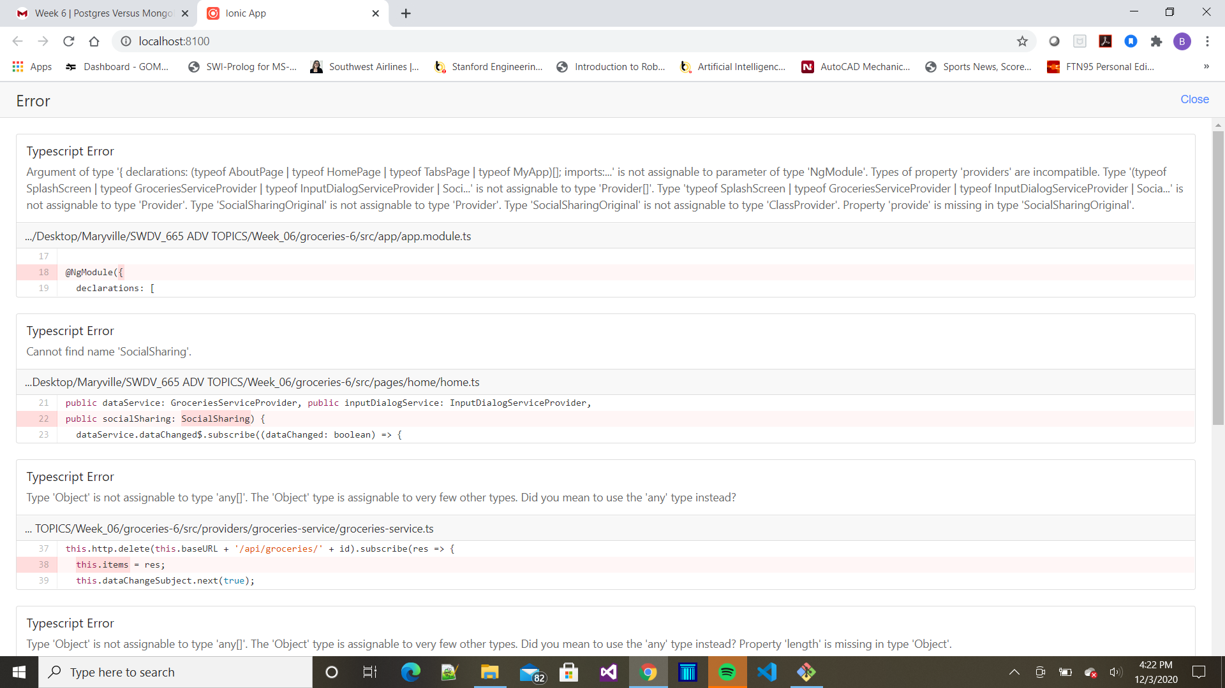

This is what happens when I try to add the android platform:

